Chemistry II-AP
Electrochemistry Notes

Electrochemistry is the study of electricity and how it relates to chemical reactions. In electrochemistry, electricity can be generated by the movement of electrons from one atom to another in a reaction known as a redox (oxidation-reduction) reaction. The study of electrochemistry has sweeping “powerful” applications, from the batteries that power our wireless gadgets to the mechanisms which power our automobiles.

I. Introduction to REDOX terms:
- discuss oxidation and reduction, OILRIG

- Example reaction(s):

II. Balancing Oxidation-Reduction Reactions

In the course so far, reactions have been balanced by the sight-inspection method. This method has been full-proof in dealing with every reaction thus encountered. This has mostly been to the fact that the ratio of atoms has changed in compounds and not the charges. In redox reactions, however, the oxidation number of an atom will change and therefore the atom-charge ratio will also change. Our sight-inspection method, which has been full-proof thus far, simply will not work. Consider the following example:

Sample Problem: Balance the following molecular reaction using the sight-inspection method:

___KOH_{(aq)} + ___KMnO_{4(aq)} + ___KI_{(aq)} → ___K₂MnO_{4(aq)} + ___KIO_{3(aq)} + ___H₂O_{(l)}

- Balancing Redox Reaction with Half-Cell Method Steps:
1. Divide the skeleton reaction into two half reactions.
2. Balance the atoms and charges
- Atoms: other atoms then oxygen then hydrogen
- Charges: add electrons to balance total charge
3. multiply the electrons so they are equal from both half reactions.
4. add half reactions and include states of matter.
[4b.] add hydroxide ions if in basic solution
5. Sight inspect to double check atoms and charges.

Example 1: Cr₂O_{7(aq)} + I⁻_{(aq)} → Cr³⁺_{(aq)} + I_{2(s)} [acidic solution]

-2-

Example 2: MnO₄¯_{(aq)} + C₂O₄²⁻_{(aq)} → MnO_{2(s)} + CO₃²⁻_{(aq)} [basic solution]

Example 3: MnO₄⁻ + I⁻ → MnO₄²⁻ + IO₃⁻ [basic solution]

- discuss molecular reactions and compare this reaction to Sample Problem from previous page

III. Overview of Electrochemical Cells
- Two methods of calculating E°_{cell}:

Method #1: E°_{cell} = SOP + SRP
SOP = standard oxidation potential SRP = standard reduction potential
(Reminder that standard conditions are 298 K and 1.0 atm)
Look at chart on the back of anion sheet - SRP table.
If the SOP of a half-reaction is needed, only the sign changes.

ex. Al⁺³_{(aq)} + 3e⁻⁻¹ -----> Al_{(s)} SRP = -1.66 v
then Al_{(s)} -----> Al⁺³_{(aq)} + 3e⁻¹ SOP = +1.66 v

Method #2: E°_{cell} = E°_{cathode} – E°_{anode}
In this method the values, found still from the back of the anion sheet, do not change sign. The subtraction in the equation handles any sign changes.

As always when presented with two methods, choose the option which makes the most sense to you and do not deviate from that method.

Two types of reactions/ cells:
Galvanic (voltaic) Cell: a spontaneous chemical reactions causes a flow of electrons
(producing a direct current)
Electrolytic Cell: a nonspontaneous reaction occurs when a direct current is applied, forcing the
reaction to take place. ex. gold plating, or the electrolysis of water.

Since no single element can have its voltage measured by itself, a reference electrode is used. Because of its reactivity, hydrogen was chosen. 2H⁺_{(aq)} + 2 e⁻ <=> H_{2(g)} SOP = SRP = 0.00 v

-3-
IV. Voltaic (Galvanic) Cells

- Discuss notation for a voltaic cell

- Standard state of redox reactions

- Components of a Voltaic Cell

The salt bridge is composed of a saturated solution of KNO₃. Its purpose is to maintain electrical neutrality of the ions. Electrons do not pass through it! Electrons only pass through the external wire.
The anode is the site of oxidation and it has a negative charge (it is the source of electrons).
The cathode is the site of reduction and it has a positive charge.
Know what physical observations (color changes, mass changes, bubbling, etc.) signify.
For electrolytic cells, the signs are reversed for the electrodes, but the processes remain the same.

Sample Problem: Draw a diagram, show balanced equations, and write the notation for a voltaic cell that consists of one half-cell with a chromium bar in a chromium(III) nitrate solution, another half-cell with a silver bar in a silver nitrate solution, and a KNO₃ salt bridge. Measurement indicates that the chromium electrode is negative relative to the silver electrode.

-4-
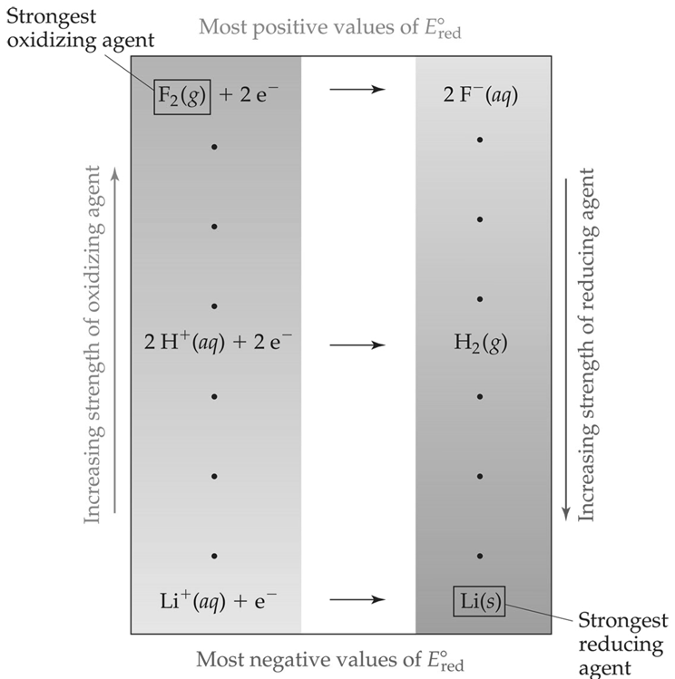
IV. Voltaic (Galvanic) Cells (continued)

- Cell Potential: Output of a Voltaic Cell
Discuss Sign Conventions

- Standard Hydrogen Electrode (SHE)

- Strength of Oxidizers and Reducers

- Connecting electrochemistry to thermodynamics: ΔGº = - nF Eº

Sample Problem: Calculate the E°_{cell} for the voltaic cell: Cr_{(s)}│Cr³⁺_{(aq)}║ Ag⁺_{(aq)} │Ag_{(s)}

Sample Problem: Lead can displace silver from solution and silver occurs in trace amounts in the ores of lead. Calculate the E°_{cell,} K_{eq,} and ∆G° from a cell created from these half reactions.

V. Nernst Equation - calculating E_{cell} at nonstandard conditions

$E_{cell}= E_{cell}^{°}- \frac{RT}{nF}lnQ$ or $E_{cell}= E_{cell}^{°}- \frac{0.0592V}{n}logQ$
At equilibrium, there is no voltage, so E = 0; then $E_{cell }^{°}= \frac{0.0592V}{n}logK$

Sample Problem: In a test of a new reference electrode, a chemist constructs a voltaic cell of a Zn/Zn²⁺ half-cell and a H₂ / H⁺ half-cell under the following conditions:
[Zn²⁺] = 0.010M [H⁺] = 2.5 M P_{i} (H₂) = 0.30 atm
Calculate the E_{cell} at 298K.

-5-

VI. Electrolytic Cells:
1. electrolysis of solutions:
a. water: 2 H₂O_{(liq)} ---------> 2H_{2(g)} + O_{2(g)}

voltage required = SOP + SRP = 0.00 v + (-1.23 v) = -1.23 volts

b. molten (liquid) NaCl: 2 NaCl_{(liq)} ----------> 2 Na_{(s)} + Cl_{2(g)}
Na⁺¹_{(aq)} + 1 e⁻¹ ---> Na_{(s)} SRP = -2.71 v
2 Cl_{(aq)}⁻¹ -------------> Cl_{2(g)} + 2 e⁻¹ SOP = -1.36 v
(Down’s Cell - important for both the production of solid sodium as well as the Cl₂ gas.)

c. brine (aqueous sodium chloride):
There are two possible reactions for each of the two half-reactions. Not only can the sodium chloride be oxidized and reduced, but the water also has the potential for both half-reactions - oxidation & reduction.

Possible reductions:
Na⁺¹_{(aq)} + 1 e⁻¹ -------> Na_{(s)} SRP = -2.71 v

2 H₂O_{(aq)} + 2 e⁻¹ -------> H_{2(g)} + 2 OH_{(aq)}⁻¹ SRP = -0.83 v

Possible oxidations:
2 Cl_{(aq)}⁻¹ -------------> Cl_{2(g)} + 2 e⁻¹ SOP = -1.36 v

2 H₂O_{(liq)} --------> O_{2(g)} + 4 H⁺¹_{(aq)} + 4 e⁻¹ SOP = -1.23 v

Discuss overvoltage. Actual voltage of oxidation of water is about -1.54 v.
(Overvoltage also occurs at the cathode, but the difference between the two possible half-reactions is still so great that it doesn’t matter.)

VII. Electroplating:
In this nonspontaneous process, a metallic cation comes out of solution to plate onto a surface. The cathode serves as the plating site, while the anode is the continuing source of the cation. The concentration of the solution is maintained in this way.

-6-
Terms associated with electrolysis and electroplating:

coulomb - unit of electrostatic attraction
volt - unit of electromotive force (potential)
ampere - unit of current; 1 Amp = 1 coulomb per second
Faraday - one mole of electrons = 96,500 coulombs ( 6.02 x 10²³ e⁻)(1.602 x 10⁻¹⁹coulombs/e⁻ )
ohm - unit of resistance (Ω)
watt - unit of power; more commonly, the kilowatt-hour is used
Three quantities needed to do calculations - quantity of metal, time, & amperage

ex.#1 How many minutes are required to plate out 75.0 grams of gold from a 2.50 M solution of auric nitrate if the current used is 12.6 amperes?
(Note: concentration of solution is not important; the charge on the cation is important!)

ex.#2 A 15.0-amp current runs for 2.20 hours through a solution of platinum(IV) acetate. How many grams of platinum metal can be plated out?

ex.#3 What is the amperage of a current that plates out 0.425 moles of nickel from a nickel(II) nitrate solution in 83.3 minutes?
(Since you want to end up with a two-unit quantity, it would be best to start with a 2-unit qty.)

Discuss problem with running a higher amperage in order to plate out metals in a shorter time.

VIII. Batteries:

Portability is a big advantage of batteries. Unfortunately, this advantage comes with a large price tag (relatively speaking). Back when electricity to the household was about $0.10 per kilowatt-hour, the cost of electricity from a common D cell battery was about $80.00 per kilowatt-hour!

Dry cells (Leclanche):
- contrast with wet cells
- not really dry
- may be regular (acidic) or alkaline

Regular Dry Cells:
Zn_{(s)} --------> Zn⁺²_{(aq)} + 2 e⁻¹
2 MnO_{2(s)} + 2 NH₄⁺_{(aq)} + 2e⁻¹ -----> Mn₂O_{3(s)} + 2 NH_{3(g)} + H₂O_{(liq)}
-7-

Alkaline batteries:
- use KOH as the electrolyte
- advantages - longer shelf-life & deliver more current over a longer time period
- disadvantage- more expensive
Zn_{(s)} + 2 OH⁻¹_{(aq)}--------> ZnO_{(s)} + H₂O_{(liq)} + 2 e⁻¹
2 MnO_{2(s)} + H₂O_{(liq)} + 2e⁻¹ -----> Mn₂O_{3(s)} + 2 OH⁻¹_{(aq)}

Lead Storage Battery: - able to act as both a galvanic cell as well as an electrolytic cell
- capable of producing direct current, but also being recharged
- both electrodes produce a common product - PbSO₄
Anode: Pb_{(s)} + SO_{4(aq)} -----------> PbSO_{4(s)} + 2 e⁻¹
Cathode: PbO_{2(s)} + SO_{4(aq)}⁻² + 4H⁺_{(aq)} + 2 e⁻¹ -----> PbSO_{4(s)} + 2 H₂O_{(liq)}

Current car batteries are basically maintenance-free, but older batteries required that the water level be checked on a very regular basis. Voltage from the two half-reactions is +2.041v. With six sets of these cells, the total voltage is just over 12 volts.

Ni-Cd (nicad) Rechargeable battery:

Anode: Cd_{(s)} + 2 OH⁻¹_{(aq)} ------> Cd(OH)_{2(s)} + 2 e⁻¹

Cathode: NiO_{2(s)} + 2 H₂O_{(liq)}+ 2 e⁻¹ --------> Ni(OH)_{2(s)} + 2 OH⁻¹_{(aq)}

Since both products adhere to the electrodes, the battery is able to be recharged, like the lead storage battery. Since the product of one reaction (hydroxide ion) is also a reactant at the other electrode, there is less chance of reactants being used up.

Fuel Cell:
- use conventional fuels, such as water or methane, to produce electricity.
For the hydrogen - oxygen fuel cell:

Anode: H_{2(g)} + 2 OH⁻¹_{(aq)} ------> H₂O_{(liq)} + 4 e⁻¹

Cathode: O_{2(g)} + 2 H₂O_{(liq)}+ 4 e⁻¹ --------> 4 OH⁻¹_{(aq)}

On the Apollo moon flights, 500 pounds of fuel was needed for the 11 day flight. The electrolyte is KOH, and the electrodes are graphite rods packed with a catalyst. Because the reactants are supplied continuously, a fuel cell does not “go dead.”

-8-
IX. Corrosion:

1. oxidation of magnesium & aluminum - does it occur?
2. oxidation of iron
20% of all iron that is manufactured is used to replace rusted iron! For the U.S., that amounts to over $200 billion, about 4% of the gross domestic product!

Requirements: must have oxygen and water present for corrosion to occur.
Rusting occurs faster in acidic conditions.
Discuss effect of salt water on rusting process.
Discuss effect of throwing rock salt on roads.

Anode: Fe_{(s)} + 2 H⁺¹_{(aq)} -----------> Fe⁺²_{(aq)} + H_{2(g)} SRP = +0.44 v
Cathode: O_{2(g)} + 4H⁺¹_{(aq)} + 4 e⁻ -------> 2H₂O_{(liq)} SOP = +1.23 v

The ferrous ion then is converted to the ferric ion: Fe⁺²_{(aq)} -----> Fe⁺³_{(aq)} + 1 e⁻¹

Rust is actually FeO(OH)_{(s)}

Because it is such a large flaky substance, this product can easily be removed from the pure iron, which then exposes more of the pure metal to further oxidation.

IX. Methods of preventing corrosion

a. painting, esp. with a paint like Rustoleum

b. using a basic solution as a coating - discuss reaction at cathode & LeChatelier’s Princ.

c. coating with metals
- tin cans
- galvanizing - use of Zn
- chrome plating
- nickel plating

d. making alloys
-stainless steel - 80.6% Fe, 0.4% C, 18% Cr, 1% Ni
other alloys of note:
Sterling silver - 92.5% Ag, 7.5% Cu
Wood’s metal - 50% Bi, 25% Pb, 12.5% Sn, 12.5% Cd
Plumber’s solder - 67% Pb, 33% Sn
Pewter - 85% Sn, 6.8% Cu, 6% Bi, 1.7% Sb
Yellow brass - 67%Cu, 33% Zn
Dental amalgam - 70% Ag, 18% Sn, 10% Cu, 2% Hg

e. keeping iron dry

f. cathodic protection - sacrificial anode

