Electrochemistry Problem Set #1
Solution Set
- Balance the following oxidation-reduction reactions using the half-reaction method.
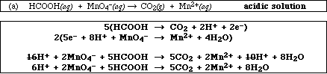
Identify the oxidizing agent MnO₄⁻identify the reducing agent HCOOH
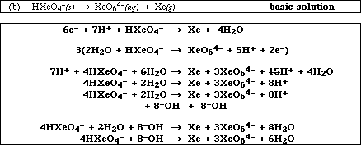
Identify the oxidizing agent HXeO₄⁻identify the reducing agent HXeO₄⁻
- Write a balanced equation for the electrode and overall cell reactions in the following galvanic celland determine Eº. Sketch the cell, labeling the anode and cathode and showing the direction of electron and ion flow.

Co(s) | Co²⁺(aq) || Cu²⁺(aq) | Cu(s)

Co(s) + Cu²⁺(aq) Co²⁺(aq) + Cu(s) Galvanic cell: Co(s) is anode (in left beaker) in a solution of Co(NO₃)₂, Cu(s) is cathode (in right beaker)
Eº_{ox} (Co) = +0.28 V, Eº_{red} (Cu) = +0.34 V in solution of Cu(NO)₃)₂, salt bridge (NaNO₃) connects the two solutions. Electrons flow from anode to cathode.
Eº_{cell} = 0.62 V
Pb(s) | Pb²⁺(aq) || NO₃⁻(aq), H⁺(aq), NO(g) | Pt(s)

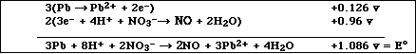

Galvanic cell: Pb (s) is anode (in left beaker) in a solution of Pb(NO₃)₂, Pt(s) is cathode (in right beaker)in solution of nitric acid and NO, salt bridge (NaNO₃) connects the two solutions. Electrons flow from anode to cathode.

- Circle the substance in each pair below that will be a stronger reducing agent:

- Al(s) or Ni(s)

- Mg(s) or Na(s)

- H₂O₂(aq) or Cl₂(g)

d. Sn²⁺(aq) or Cl⁻(aq)

- Create a functional Galvanic cell given the following: On the left side of the cell there is a 1.00M aqueous solution of H₂C₂O₄ with an inert platinum electrode. On the other side, there is a solid iron electrode sitting in a solution of 1.00M iron(III) nitrate. Finish drawing the cell and label the anode, cathode, electrodes, solutions and all parts of the cell. Write and balance the half reactions and overall cell reaction. Calculate Eº_{cell}, ΔGº_{rxn} and K – show your work. Indicate where ALL charged particles flow and their identity. Write the short hand notation for the cell. Use Appendix D for relevant data.

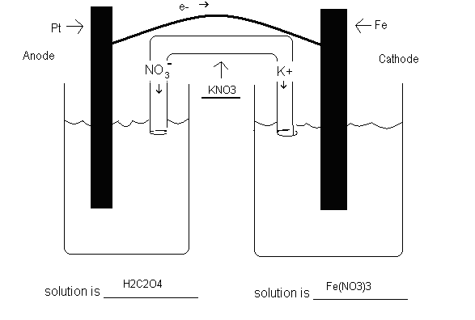
Oxidation ½ reaction: H₂C₂O₄(aq)  2 CO₂(g) + 2 H⁺(aq) + 2 e⁻Eº_{ox} = +0.49 V

Reduction ½ reaction: Fe³⁺(aq) + 3 e⁻ Fe(s) Eº_{red} = -0.04 V

Cell reaction 3 H₂C₂O₄(aq) + 2 Fe³⁺(aq)  2 Fe(s) + 6 CO₂(g) + 6 H⁺(aq) Eº_{cell} = 0.45 V

Short hand notation is Pt(s) | H₂C₂O₄(aq) | CO₂(g), H⁺(aq) || Fe³⁺(aq) | Fe(s)

ΔGº_{rxn} = -n F Eº = -6 mol e (96.5 kJ / V mol e)( 0.45 V) = - 2.6 x 10² kJ

Eº = (RT / n F) ln K plug in and solve for ln K; ln K = 105.16 so

K = 4.7 x 10⁴⁵

- The oxidizing agent reacts at the (cathode or anode). The reducing agent reacts at the (cathode or anode).

- Calculate Eº, ΔGº, and K for the following reaction
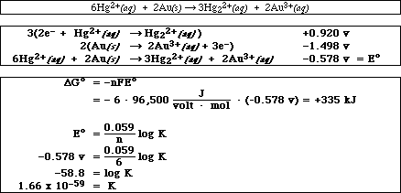
- A voltaic cell is constructed in which the reaction is,
- If the [Cr³⁺] = 1.00 M, [Sn⁴⁺] = 0.500 M and the [Sn²⁺] = 0.025, calculate E_{cell} at 25 ºC.
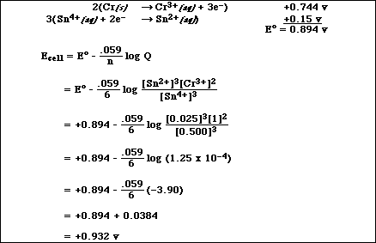
- Calculate [Cr³⁺] for the reaction if the [Sn²⁺] is 1.00 M and [Sn⁴⁺] is 1.00 M and the measured cell potential is +0.994 volts.
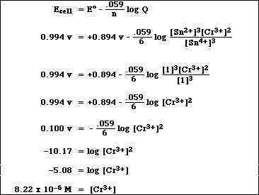
- Compare an electrochemical cell with an electrolytic cell by completing the following table:

 | Electrochemical Cell | Electrolytic Cell
Energy Conversion | chemical → electrical | electrical → chemical
Spontaneous  Chemical Reaction? | yes | no
Value of E°  (positive or negative) | positive | negative

- A Cr³⁺(aq) solution is electrolyzed using a current of 13.5 A. What mass of Cr(s) is plated out after 3.00 days?

13.5 C/s * 3 days * 24 hr/ 1 day * 3600 sec/ 1 hr = 3.499 x 10⁶ C

3.499 x 10⁶ C * 1mol e⁻ / 96500 C * 1 mol Cr/3 mol e⁻ * 52.00 g Cr / 1mol Cr = 628 g Cr

- In the electrolytic cell shown here, an iron nail is being plated with copper.

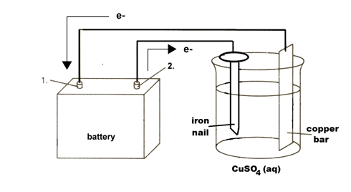
a. Which object, the iron nail or the copper bar, should be connected to the negative post of the battery?
the iron nail
- Write the equation for the half-reaction that occurs at the cathode of the electrolytic cell.
The iron cannot be reduced further so electrons are being placed on the surface of the metal to react with the copper ion in solution
Cu²⁺ + 2 e⁻→ Cu
- Write the equation for the half-reaction that occurs at the anode of the electrolytic cell.
Electrons are being with draw n from copper, oxidation, in order to replenish the copper ions concentration in solution
Cu → Cu²⁺ + 2 e⁻
d. Show on the diagram the flow of electrons both entering and leaving the battery.
see diagram above

