Chemistry I-H
Gas Laws Theory Worksheet

1. B Samples of SO₂(g) and N₂(g) contain equal numbers of molecules. If the gases are at STP, the samples have: A) equal no. of atoms; B) equal volumes; C) the same mole. mass; D) the same density.

2. D A flask containing molecules of gas A and a separate flask containing molecules of gas B are both at the same temperature. Gases A and B must have equal
A) volumes; B) masses; C) pressures; D) average kinetic energies

3. D At constant temperature, which 10 mL sample, measured at STP, will uniformly take the shape and volume of a 100 mL container into which it is placed?
A) water; B) mercury; C) sodium chloride; D) carbon dioxide

4. C When the average kinetic energy of a gaseous system is increased, the average molecular velocity of the system
A) increases and the molecular mass increases
B) decreases and the molecular mass increases
C) increases and the molecular mass remains the same
D) decreases and the molecular mass remains the same

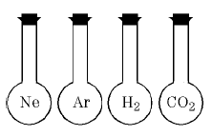
5. B The diagram shown represents four 500 mL flasks. Each flask contains the gas represented by its symbol. All gas samples are at STP. Each flask contains the same number of
A) atoms only; B) molecules only; C) atoms and molecules; D) atoms but different no. of molecules
Consider the following table for the next set of questions:

P (atm) | V (mL)
0.5 | 1000
1.0 | 500
2.0 | 250
3.0 | ???

6. B The table shows the changes in the volume of gas as the pressure changes at constant temperature. Which equation best expresses the relationship between pressure and volume for the gas?
A) $\frac{P}{V}$= 500 atm∙mL; B) PV = 500 atm∙mL; C) $\frac{V}{P}$= 500 atm∙mL; D) PV = $\frac{1}{500}$ atm∙mL

7. A The data presented in the table is consistent with which gas law?
A) Boyles’ B) Charles’ C) Amonton’s D) Avogadro’s

8. A Based on the chart, (and without calculation) the volume of this gas at 3.0 atm is most likely
A) 200 mL; B) 100 atm; C) 125 atm; D) 50 atm
-2-

9. D Under the same conditions of temperature and pressure, a liquid differs from a gas because the particles of the liquid
A) are in constant straight-line motion; B) take the shape of the container they occupy;
C) have no regular arrangement; D) have stronger forces of attractions between them.

10. C Which property of a sample of mercury is different at 320K than at 300K?
A) atomic mass; B) atomic radius; C) vapor pressure; D) melting point.

11. D According to the kinetic molecular theory, which assumption is correct?
A) gas particles strongly attract each other; B) gas particles travel in curved paths;
C) the volume of gas particles prevents random motion
D) energy may be transferred between colliding particles

12. B The table below shows the temperature, pressure, and volume of the five samples. Which sample contains the same number of molecules as sample A? Explain.
Sample | Substance | Temp. (K) | Pressure (atm) | Volume (L)
A | He | 273 | 1.00 | 22.4
B | O₂ | 273 | 1.00 | 22.4
C | Ne | 273 | 2.00 | 22.4
D | N₂ | 546 | 2.00 | 44.8
E | Ar | 546 | 2.00 | 44.8

13. A As the temperature of a given sample of a gas decreases at constant pressure, the volume of the gas
A) Decreases B) Increases C) remains the same

14. A Which graph shows the pressure-temperature relationship expected for an ideal gas?

A) | 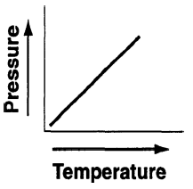 | B) | 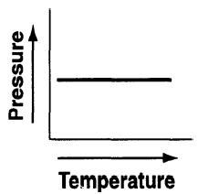 | C) | 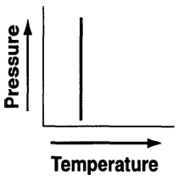 | D) | 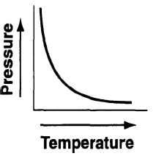

15. B The concept of an ideal gas is used to explain
A) the mass of a gas sample; B) the behavior of a gas sample;
C) why gases are monatomic; D) why some gases are diatomic.

16. A The kinetic molecular theory assumes that the particles of an ideal gas
A) are in random, constant, straight-line motion; B) are arranged in a regular geometric pattern
C) have strong attractive forces between them;
D) have collisions that result in the system losing energy.
-3-

17. A Which diagram represents a gas in a closed container?

A) | 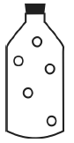 | B) | 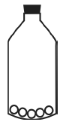 | C) | 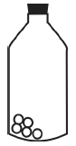 | D)

18. B The table below shows data for the temperature, pressure and volume of four gas samples.
Gas  Sample | Temp. (K) | Pressure (atm) | Volume (L)
A | 100.0 | 2.00 | 400.0
B | 200.0 | 2.00 | 200.0
C | 100.0 | 2.00 | 400.0
D | 200.0 | 4.00 | 200.0

Which gas samples have the same total number of molecules?

A) A and B; B) A and C; B) B and C; D) B and D.

19. B The density of a gas is 2.0 grams per liter at STP. Its molecular mass is approximately
A) 67 g/mol; B) 45 g/mol; C) 22 g/mol; D) 8.0 g/mol.

20. D At which conditions of temperature and pressure would the molecules of a gas have the greatest average kinetic energy?
A) 273K and 3.00 atm; B) 10°C and 29.4 psi; C) 50.0°C and 405 kPa; D) 373K and 1 atm.

21. A The temperature of a sample of matter is a measure of the
A) average kinetic energy of its particles; B) average potential energy of its particles;
C) total kinetic energy of its particles; D) total potential energy of its particles.

22. D Which graph represents the relationship between pressure and volume for a sample of an ideal gas at constant temperature?

A) | 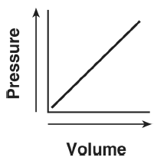 | B) | 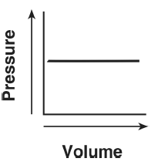 | C) | 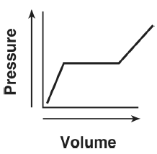 | D) | 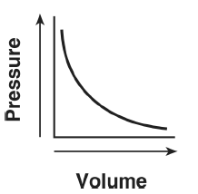

-4-

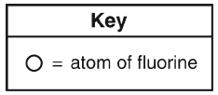
23. B Which particle diagram represents the arrangement of fluorine gas molecules in a sample at 95K and standard pressure?

A) | 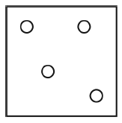 | B) | 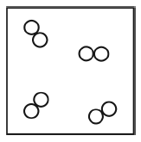 | C) | 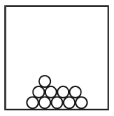 | D) | 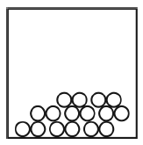

24. A soft-drink bottling plant males a colorless carbonated beverage called soda water. During production of the beverage, carbon dioxide gas is dissolved in water at a pressure greater than 1.00 atm. The bottle containing the solution is capped to maintain that pressure above the solution. As soon as the bottle is opened, fizzing occurs due to CO₂ (g) being released from the solution.

(a) Comment on the pH of the solution created when carbon dioxide is dissolved to make this solution.
Nonmetal oxides produce acid in solution, therefore the pH will be less than 7.

(b) Explain why CO₂(g) is released when a bottle of soda water is opened.
The pressure above the solution decreases so the CO₂ is less soluble in solution. (i.e. the CO₂ escapes out of the solution).

25. A sample of helium gas is in a closed system with a movable piston. The volume of the gas sample is changed when both the temperature and the pressure of the sample are increased. The table below shows the initial temperature, pressure, and volume of the gas sample, as well as the final temperature of the sample.
Condition | Temp. (K) | Pressure (atm) | Volume (L)
Initial | 200.0 | 2.00 | 500.0
Final | 300.0 | 7.00 | ?

(a) Compare the total number of gas particles in the sample under the initial conditions to the total number of gas particles in the sample under the final conditions.
The total number of gas particles is the same under the initial and final conditions due to the conservation of matter.

(b) What is the final volume of the gas? Does the volume increase or decrease?
P₁V₁/T₁ = P₂V₂/T₂ => V₂ = (P₁V₁T₂) / (P₂T₁)
= (2.00 atm x 500.0L x 300.0K) / (7.00atm x 200.0K)
= 214 L

(c) Using your explanation from (a), rationalize the calculation from (b).
The pressure increases appreciably while the temperature only increases marginally. This will result in an overall decrease in volume.

