Chemistry II – AP

Organic Chemistry Introduction

Alkanes and Stereochemistry

All chemicals in the Universe – water, table salt, everything – were forged in the center of stars. Chemistry is the study of matter and the changes it may undergo. Organic Chemistry is a sub-discipline of Chemistry that studies the specific study of the structure, properties, and reactions of organic compounds and organic material (matter in its various forms that contain carbon atoms).

**Our Universe**

Our universe is composed of Matter and Energy. It is the duty of the Chemist to observe, describe, predict and hypothesize the properties and functions of Matter and Energy and how they may interact. This idea is summed up in the mass-energy equivalence equation proposed by Albert Einstein in his Theory of Relativity:

E = mc2

Where,

E = energy (measured in Joules)

m = mass of object

c = the speed of light (3.00x108 m/s)

Four forces dominate the physical universe:

1. Gravity – 1042 weaker than the electromagnetic force
2. Strong Force – holds protons together in the nucleus
3. Weak Force – internuclear force holds neutrons; 1010 weaker than the EM force
4. Electromagnetic Force – ALL OF CHEMISTRY



Coloumb’s Law is an application of the Electromagnetic force

Chemical reactions take place in this universe because of Gibbs Free Energy.

∆G = ∆H – T∆S

∆G ≡ Gibbs Free Energy

∆H ≡ enthalpy

∆S ≡ entropy (degree of randomness or disorder)

**Line Drawings**

In organic chemistry, line drawings are used as a short-hand notation because of the ubiquitous nature of elements such as carbon and hydrogen.

Rules:

1. Carbons and hydrogens are rarely drawn.
2. If there is a lone pair on a Carbon, it needs to be shown.
3. Heteroatoms – O, N, P, S, Cl, etc.—with hydrogens must be shown.
4. Lone pairs on heteroatoms do not have to be shown.

-2-

To be successful in Organic Chemistry, it is important to remember everything you learned in kindergarten.

Kindergarten Lessons:

1. Count to eight (Octet Rule)
2. Alphabet (C, H, O, N, P, S)
3. Bonding: sharing, compromise, greed, stealing

* Know the bonds C, H, O and N
* In organic chemistry, Carbon ALWAYS has 4 bonds

1. Drawing and connecting the dots



1. The North Pole is attracted to the South Pole (electrons and protons).

EXAMPLES

A compound like C5H12 can be written as

CH3CH2CH(CH3)CH3  (also called a structural line formula) OR

is the same thing as 

When it comes to recognizing structures that may look different – but are in fact actually the same – remember that as long as bonds are not broken or changed (morphed from single to double or triple bonds) these compounds are the same.

If a bond is broken, yet the compound keeps the same number of specific atoms, that is a compound starts with 4 carbons, 8 hydrogens, and 2 oxygens and ends with the same atom count, these compounds are known as **constitutional isomers**.



In-class examples: Write chemical formulas for these organic compounds:



-3-

**I. ALKANES**

Alkanes also known as “saturated” hydrocarbons or the “paraffin” series because all bond sites between carbon atoms and between carbon and hydrogen are single bonds.

In naming the alkanes, the stem is based on the number of carbon atoms in the ***longest continuous chain****.*

Be careful because the chain may be twisted in several directions. Groups that are attached to the chain of hydrocarbons are called “substituted” or “alkyl” groups. The ending for an alkane is “-*ane*”.

Prefixes that represent the different number of carbon atoms are as follows:

# carbons prefix # carbons prefix # carbons prefix # carbons prefix

1 meth- 4 but- 7 hept- 10 dec-

2 eth- 5 pent- 8 oct- 11 unidec-

3 prop- 6 hex- 9 nona- 12 dodec-

Ex. CH3CH2CH2CH3 is called butane, also known as *n*-butane because this is the *normal* isomer of butane.

If the substituted group contains hydrocarbons, the name of the substituted group uses the above prefixes.

All substituted groups, including halogens and alkyl groups, are listed in **alphabetical order**. Numbers are used to designate the location of the substituted group on the **parent chain**. Prefixes such as “di-“ and “tri-“ are **not** considered in determining alphabetical order.

Ex. CH3CH2CHCH2CHCH2CH2CH3

| | is called 5-ethyl-3-methyloctane

CH3 CH2CH3

If two of the same type of alkyl groups are attached to a single carbon in the parent chain, the number is repeated. CH3

|

Ex. CH3CH2CH2CH2CCH2CHCH2CH3

| | is called 3-ethyl-5,5-dimethylnonane

CH3 CH2CH3

When trying to draw a structural formula from a condensed formula, alkyl groups are put in parentheses and follow the carbon to which they are bonded. If a saturated hydrocarbon has –(CH2)- in the condensed formula, that is part of the parent chain.

Ex. CH3CH(CH3)(CH2)4CH(CH2CH3)CH2CH2CH3 Name: 7-ethyl-2-methyldecane

Sample Problem:

(1) Name the following: CH3(CH2)3C(CH3)2C(CH2CH3)2C(CH3)3

(2) Provide a line drawing.

-4-

**(Answer to previous problem: 3,3-diethyl-2,2,4,4-tetramethyloctane)**

SHAPES OF SIMPLE AND CYCLIC ALKANES

In drawing traditional Lewis Structures, you are used to drawing the substances as linear. For example, drawing a molecule of ethane (C2H6) is not, and very well should not, be a problem. We draw ethane like this:

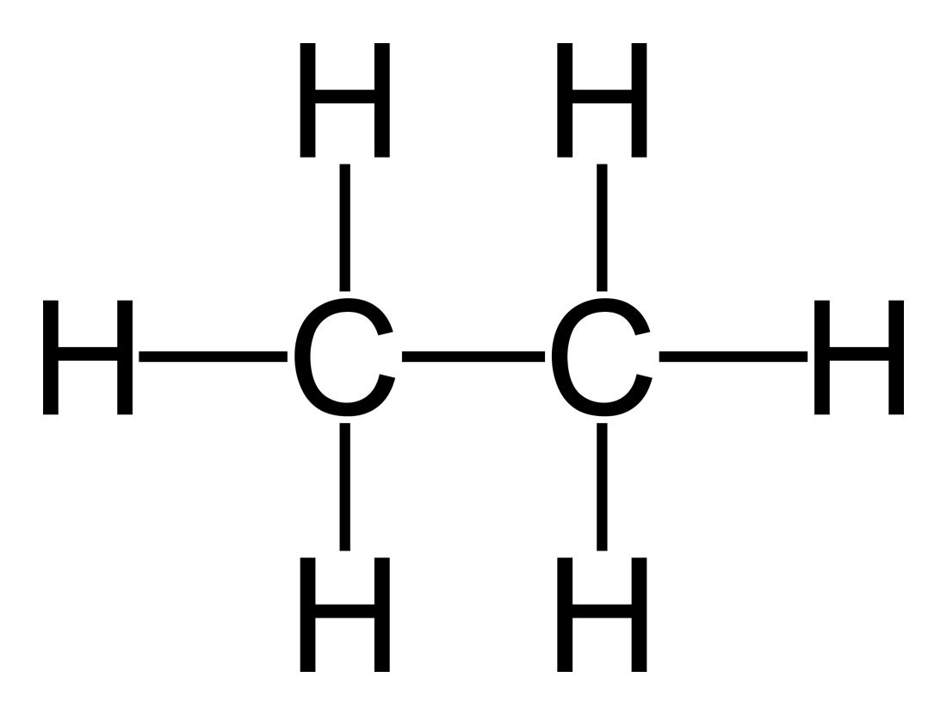

The problem, as we have studied in detail before, is that this two dimensional representation is not at all reflective of the three dimensional reality of the molecule.

Instead, organic chemists use Newman Projections to indicate the three-dimensionality of these structures. Newman Projections require the chemist to shift their perspective to interconvert between these representations







Line drawing saw-horse projection Newman Projection

The Newman Projection displays the apparent angle between a hydrogen (or other substituent) on the front carbon and a hydrogen (or other substituent) on the back carbon. The back carbon is represented by the circle and the connecting prongs. The Newman projection is converted from the saw-horse projection by “looking down” the C-C bond (as shown in the figure above). The importance of drawing Newman Projections is to gain the ability to describe the relative position of two groups without drawing the full structure.

Discuss: DA, eclipsed, anti configurations & gauche interactions. Which of these interactions is most stable?

Example Problem: Draw a Newman projection for the most stable form of butane. Consider looking from

C-2 to C-3 (C2 🡪 C3).

-5-

Consider now the shape of a cyclic alkane. Cyclohexane, a mere hexagon, is perhaps the easiest and most straightforward to imagine. Each carbon in cyclohexane is sp3hybridized; meaning that each carbon and its constituents must adopt approximate bond angles of 109.5°. Once again, our simplified, two-dimensional, geometric shape fails. For cyclic alkanes we adopt **chair conformations** to represent the three dimensional nature of these shapes. Below are generalized shapes for chair conformations:



Chair conformations can be flipped! (To show resonance)

Discuss: axial and equatorial, repulsion of electronic clouds



Example Problem: Draw the two resonance forms for cis-1,2-diethylcyclohexane.

PHYSICAL PROPERTIES OF ALKANES

Two main properties: water solubility and boiling point.

Alkanes are not very water soluble because of the difference in electronegativity of hydrogen and carbon. There are no partially positive and partially negative regions to be attracted to the partially positive hydrogen and partially negative oxygen in water. Ultimately, there are not enough strong interactions to cause alkanes to dissolve. Look at the chart comparing the boiling points and solubility of selected alkanes. Notice how the boiling point of the alkane increases as the chain length (or amount of carbons) increases. The slight increase in solubility from methane to butane is attributed to the ability of small hydrocarbons to fit into spaces between water molecules.

The shape of the alkane also influences the boiling point. The more linear the molecules have the higher boiling points. This is due to increased surface area involved in van der Waals attractive forces. This is best done when comparing alkanes of near equal chain length; like *n*-pentane and neopentane.

-6-

|  |  |  |
| --- | --- | --- |
| Compound | Water Solubility  (g/100 mL of water) | Boiling Point (°C) |
| methane | 0.0025 | -161 |
| ethane | 0.0064 | -88 |
| propane | 0.013 | -42 |
| butane | 0.039 | -0.5 |
| pentane | 0.036 | 36 |
| hexane | 0.0095 | 69 |
| heptane | 0.0025 | 98.4 |

Example Problem: Consider these following molecules: (A) methane, (B) pentane, (C) 2-methylbutane.

Which of these molecules has the lowest water solubility? The highest boiling point?

REACTION CHEMISTRY OF ALKANES

Generally, alkanes play a major role in some incredibly boring chemistry:

(1) combustion, (2) organismal signaling, (3) Free Radical Halogenation

Free Radical Halogenation: the addition of a halogen (we use Cl and Br) to an alkane.

Discuss: Cl2/light and Br2/heat combinations. Why only Cl and Br mechanisms?

Example Problems: **CH3CH3 + Cl2 ------hv-----> CH3CH2Cl + HCl**

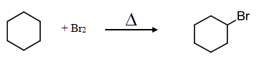

Mechanisms are detailed step-by-step processes showing how reagents combine to form products. Curved arrows are used to show the movement, or push, of electrons. (1 electron = single-headed, 2 electrons = double)

Rule: halogen will bond to the most substituted carbon in the molecule. (Compare and contrast butane vs.

2-methyl butane).

Bromine gives one major product (most substituted). Chlorine gives multiple products but for the sake of ease let’s draw the major product for chlorine reactions the same as bromine reactions.

-7-

Example Problem: Propose a mechanism for the following reaction:

Ethane is exposed to chlorine gas in the presence of light (as a catalyst).

Propose a detail mechanism for when cyclohexane is immersed in liquid bromine and exposed to heat.



Sample Problems:





**II. STEREOCHEMISTRY**

Stereochemistry (*stereo* = three dimensionality) involves the study of the relative spatial arrangement of [atoms](http://en.wikipedia.org/wiki/Atom) that form the structure of [molecules](http://en.wikipedia.org/wiki/Molecule) and their manipulation. An important branch of stereochemistry is the study of [chiral](http://en.wikipedia.org/wiki/Chirality_%28chemistry%29) molecules. It may also be called 3D Chemistry.

Chiral molecules are ones that do not contain a plane of symmetry. When a molecule does not have a plane of symmetry it means that it is not superimposable on its mirror image. A common, every-day, example of chirality are your hands. In fact, the word “chirality” comes from the Greek word “hand” and means handedness.

Chain molecules are perhaps the easiest examples to study chirality. Cyclical alkanes are a bit more difficult to see chirality. Be sure to remember that in order to atom to stereogenic (chiral) it must be attached to **four different groups**. Chiral atoms can technically be any atom (P, S, N, etc.) but we will only study carbon.

-8-

Identifying stereogenic atoms and chirality:

Let’s take a look at the ethane molecule yet again:

There are no chiral atoms in ethane. Each carbon is attached to three hydrogens.

We use wedges and dashes to show three-dimensionality in a chain molecule. The wedge represents a group coming out of the plane of the paper, whereas a dash represents a group going behind the plane of the paper.

 

one chiral center no chiral centers (internal plane of symmetry)

Example Problem: Indicate the chiral center by placing a star (*) near the central atom for the following:



Naming Molecules with the *R,S* System (Cahn-Ingold-Prelog)

Discuss: Fisher diagrams (projections), wedges and dashes, setting up atoms in diagram

Steps:

1. Draw Fisher diagrams

2. Prioritize the groups according to the atomic weights of the attached atoms

3. Using pair-wise switches, swap the groups so that the largest is on the bottom and the smallest is on top.

4. When traveling along the horizontal from the biggest to smallest, if going left the molecule is *S*, if right the molecule is *R*.

Example Problem #1: Indicate whether the following molecule is R or S.

Example Problem #2: Indicate whether the following molecule is R or S: 2-chloro-2methylbutane

Discuss: switching molecules from R to S, significance of chiral molecules, different systems (D and L) used by Biochemists and Molecular Biologists