Chemistry II-AP
Potential Energy Diagrams Problem Set

Use the following potential energy diagram to answer questions 1-8 below:
╪

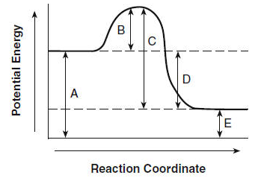╪
F

1. exothermic Is the overall reaction, as shown, exothermic or endothermic?

2. B Which letter represents the activation energy for the forward reaction?

3. C Which letter represents the activation energy for the reverse reaction?

4. D Which letter represents the enthalpy change (∆H) for the forward reaction?

5. A Which letter represents the energy of the reactants?

6. E Which letter represents the energy of the products?

7. What two conditions must be met in order for a reaction to occur according to Collision (State) Theory?

Collisions have to be effective and they must meet these criteria in order to be considered effective:
1. They must collide with the appropriate spatial orientation.
2. They must collide with enough energy to overcome an activation barrier (activation energy).

8. On the diagram above draw a line indicating the energy of the activated complex. Label this line “F”. Draw the symbol for the activated complex in the appropriate location.

See diagram above.

-2-

Use the following potential energy diagram below to answer questions 9 - 22:
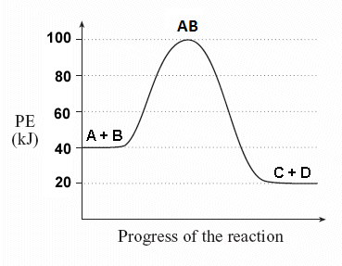
E_{A, reverse}
E_{A, forward}

9. EXO Is the overall reaction, as shown, exothermic or endothermic?

10. + 60 kJ What is the value of the activation energy for the forward reaction? Be sure to include the appropriate sign.

11. +80 kJ What is the value of the activation energy for the reverse reaction? Be sure to include the appropriate sign.

12. -20 kJ What is the value of the enthalpy change (∆H) for the forward reaction? Be sure to include the appropriate sign.

13. +20 kJ What is the value of the enthalpy change (∆H) for the reverse reaction? Be sure to include the appropriate sign.

14. ENDO Is the reverse reaction exothermic or endothermic?

15. AB Which species (or substance) forms the activated complex?

16. AB Which species or set of species has the highest potential energy?

17. What is the relationship between potential energy and kinetic energy?

The relationship between PE and KE is an inverse relationship.
-3-

18. C & D Which species or set of species has the highest kinetic energy?

19. AB Which species or set of species has the weakest bonds?

20. C & D Which species or set of species has the strongest bonds?

21. Which would be faster, the forward reaction of the reverse reaction? Explain.

The forward reaction would be faster because it has a smaller activation energy.

22. Show the Activation Energy for the forward reaction and the Activation Energy for the reverse reaction on the graph above.
See graph above

Answer the following true/false questions about any general, arbitrary reaction.

23. T – F As reactant particles approach each other before a collision, the potential energy goes down while the kinetic energy goes up.

24. T – F As particles of newly formed products move away from one another, the potential energy goes down, while the kinetic energy goes up.

25. T – F As reactant molecules approach each other, they exert attractive forces on each other. Thus, as they move together, their speed decreases and their Potential Energy increases.

26. State the meaning of the activated complex.

The activated complex is the temporary arrangement of atoms as a transition state between reactants and products. It is represented at the top of the potential energy “hill” in a PE diagram.

27. State the meaning of the activation energy.

The activation energy (E_{A}) is the minimum kinetic energy reactant molecules must possess in order to have viable collisions to form the activated products (and then, eventually, the products).

28. Chemical reactions occur when reactants collide. For what reasons, if any, may a collision fail to produce a chemical reaction?

Think collision theory: (1) There is not sufficient energy to overcome the activation barrier and/or (2) They did not collide in the correct spatial three-dimensional orientation.

-4-

Use the following potential energy diagram to answer the following questions.

29. (a) Indicate whether this reaction is exothermic or endothermic and (b) determine the heat of the reaction.
a) ENDOTHERMIC b) ∆H = +85 kJ (be sure to include the proper sign)

30. +150 kJ What is the activation energy for the catalyzed forward reaction?

31. +295 kJ What is the activation energy for the forward reaction (non-catalyzed)?

32. +165 kJ What is the activation energy for the reverse reaction (catalyzed)?

33. How does a catalyst increase the rate of a chemical reaction? Be careful. Be sure to use correct and appropriate chemical language and theory.

A catalyst speeds up a reaction by lowering the activation energy. NEVER!

A catalyst speeds up a reaction by providing an alternative pathway of lower energy. CORRECT!

